**NSAP - Indira Gandhi National Old Age Pension Scheme:**

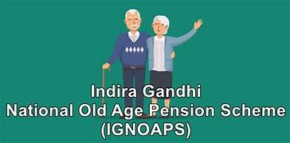

The scheme is implemented as part of the National Social Assistance Program (NSAP) of the Ministry of Rural Development, Government of India. It is a non-contributory scheme and provides a monthly income for citizens or to refugees above 60 years, who have no other source of income.

**Eligibility**

* Age: 60 years and above
* Should be Below Poverty Line (BPL).

**Benefits**

A monthly pension of Rs 600 - Rs 1000 depending upon the state share of the pension.

**How to apply**

Given below are the steps that the applicant must follow to apply to the IGNOAP Scheme.

* To apply to this scheme, the applicants in the rural area must visit the Block Development Office and the District Social Welfare Officer to apply for the IGNOAP scheme in the urban area.
* Visit the Social Welfare Department in your area and get the application form. Provide appropriate details in the form when filling it. The form contains the following fields:  
  • State/District/Block  
  • Name of the village panchayat  
  • Society name  
  • Beneficiary name  
  • Heir’s name  
  • House number  
  • Gender  
  • Age in years  
  • Date of birth  
  • Birth certificate  
  • Annual income and certificate /BPL card  
  • Domicile certificate  
  • Certificate issuance date  
  • EPIC Number

Some of the mandatory documents include BPL card, photo, Aadhaar Number, Bank Pass Book, Age proof certificate. The duly filled form must be attached with the supporting documents and submitted to the social welfare officer. The application will be thoroughly scrutinized and verified by the social welfare officer. The Social Welfare Department will then recommend the beneficiaries to the district social welfare officer. If the verification process is complete and the form is sanctioned by the district social welfare officer, the final sanction would be done by District Level Sanctioning Committee.

LINK:  
<https://www.tnesevai.tn.gov.in/Pages/ServiceList.aspx>